**Bootcamp Day 3 Assignment: Docker**

SSH into EC2 instance where Docker is installed

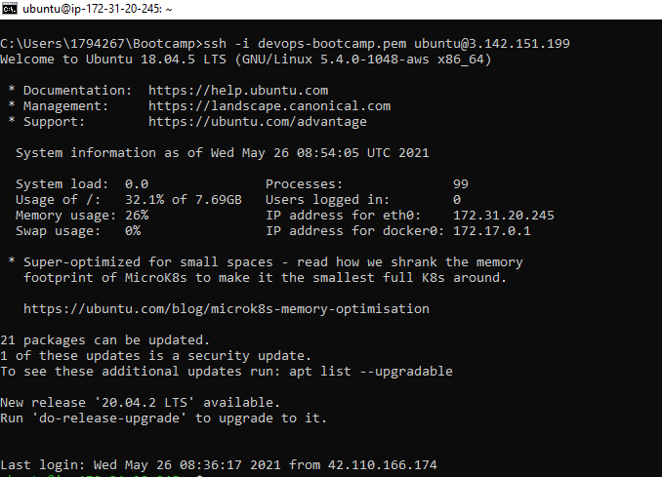

#Creating new directory for assignment’s solution

**$ mkdir docker-demo**

**$ cd docker-demo**

# Cloning github repository

**$ git clone https://github.com/shubhamkushwah123/bootcamp10.git**

# List all file for cloned repo

**$ cd bootcamp10**

**$ ls**

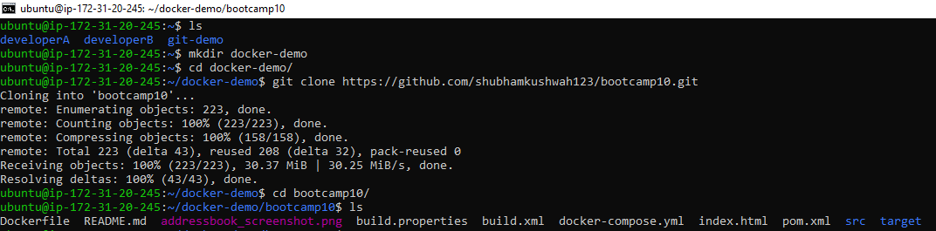

# Copying index.html file to previous directory

**$ cp index.html ../**

# Creating Dockerfile with nginx as base image to host index.html file

# Listing docker images before build Dockerfile to create image out of it

**$ docker images**

# Building Dockerfile to create Docker Image out of it

# Here *–t* is used to define tag of image to be created and **.** is used to tell docker build command where our Dockerfile is located.

# Tag of docker image is having certain pattern to follow

**mdanwarjamal** ==> user’s docker hub account name

**bootcamp12-docker-demo** ==> docker image name

**1.0** ==> version of image

**$ docker build –t mdanwarjamal/bootcamp12-docker-demo:1.0 .**

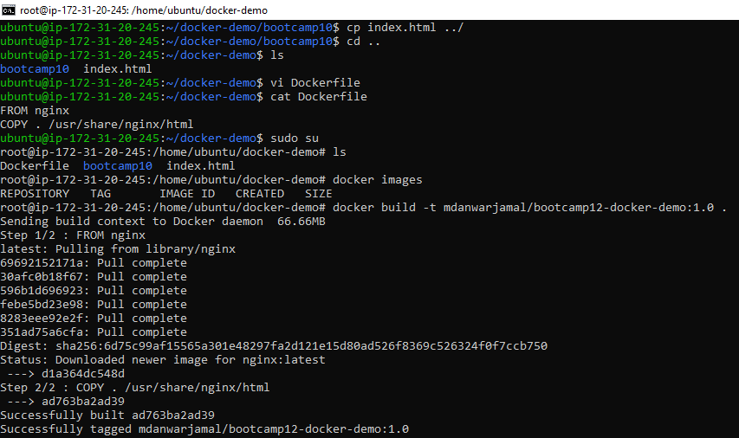

My Docker Hub Account before pushing image

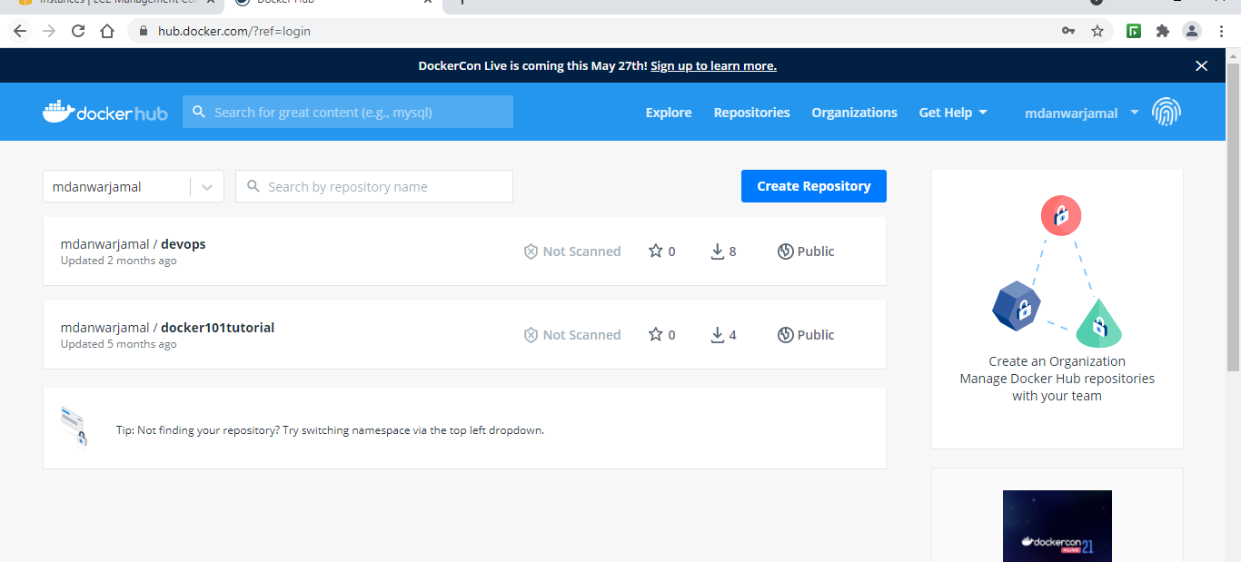

# After build is successful, image is created that can be verified using

**$ docker images**

# Login into Docker Hub from CLI

**$ docker login**

Username:

Password:

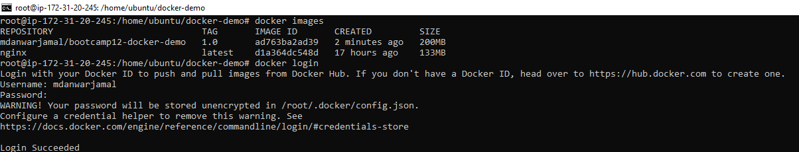

# Pushing Docker Image from Local to Docker Hub Repository

**$ docker push mdanwarjamal/bootcamp12-docker-demo:1.0**

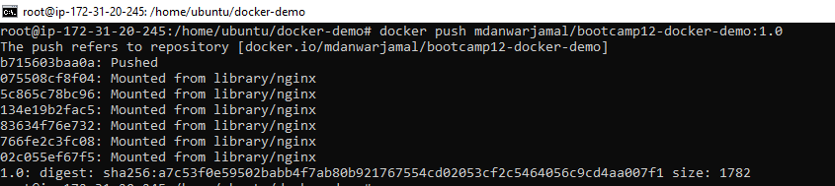

After push is successful, image is showing up in Docker Hub

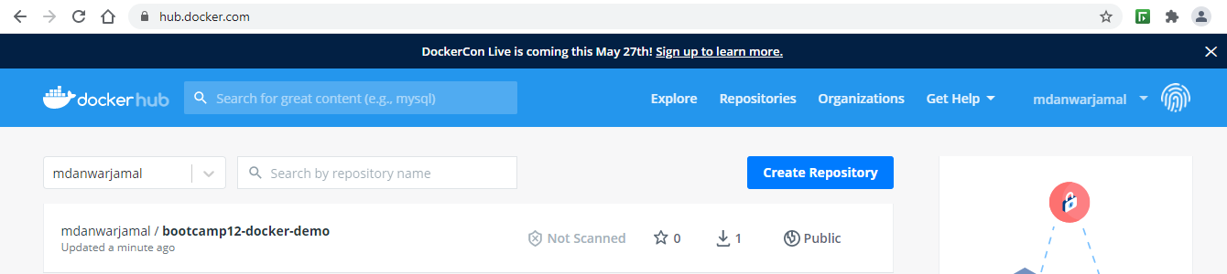

#Removing existing docker image so that can demonstrate docker pull is working as expected

**$ docker rmi mdanwarjamal/bootcamp12-docker-demo:1.0**

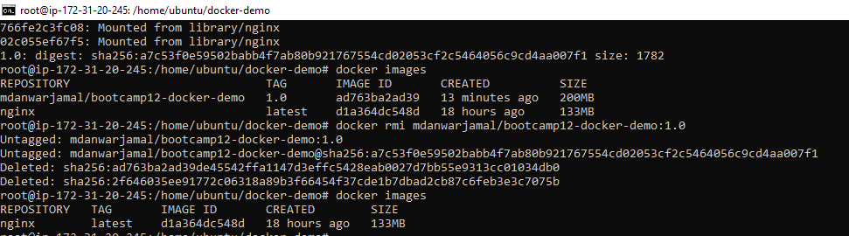

# Puling the docker image from Docker Hub

**$ docker pull mdanwarjamal/bootcamp10-docker-demo:1.0**

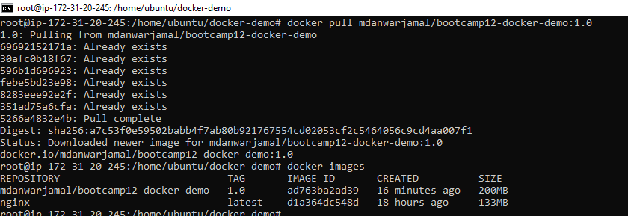

# After pull is successful, pulled image is showing up in the list

**$ docker images**

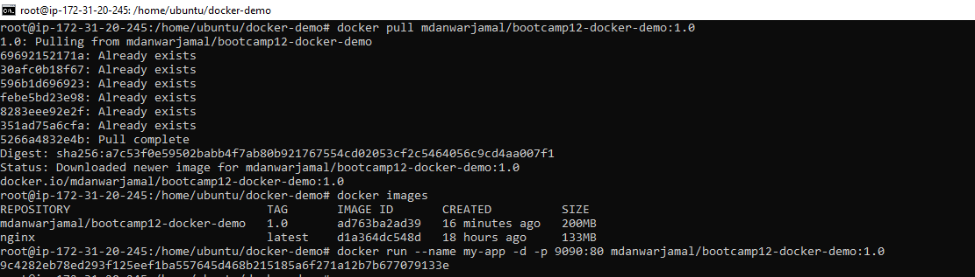

# Running the docker pulled docker image

# --name Name of docker container to be created after run command

# -d Run Container in detached/ daemon mode

# -p 9090:80 is to expose port 9090 of host machine for port 80 inside container

**$ docker run –name my-app –d –p 9090:80 mdanwarjamal/bootcamp12-docker-demo:1.0**

# List all running docker containers

**$ docker ps**

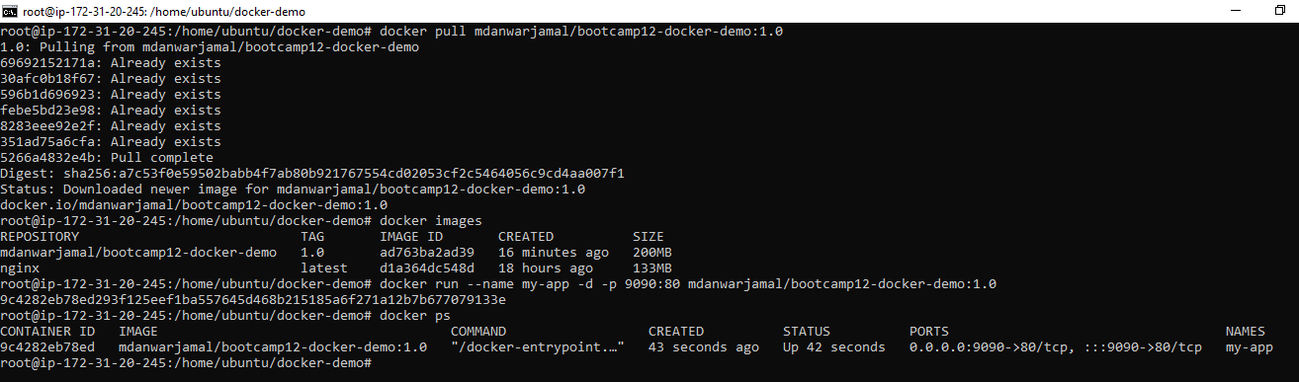

Accessing index.html hosted over nginx server at http://<IP>:9090

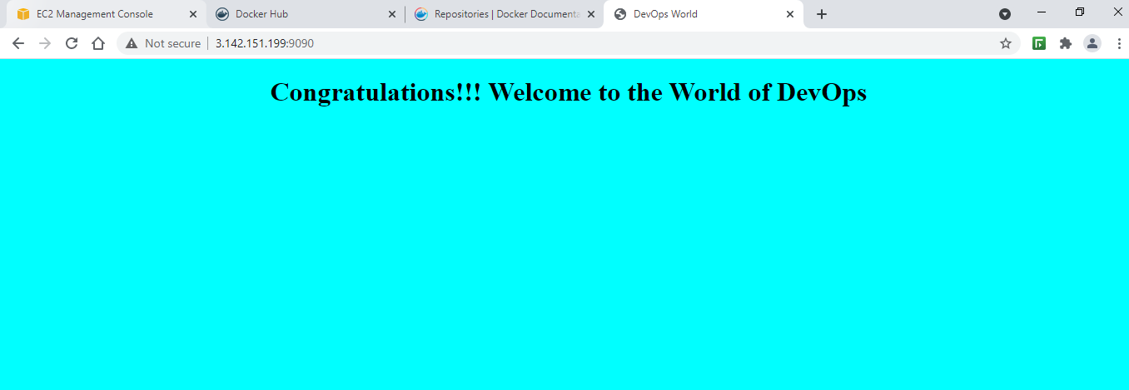

# Stopping the already running container my-app using docker containerid

**$ docker stop 9c4...8ed**

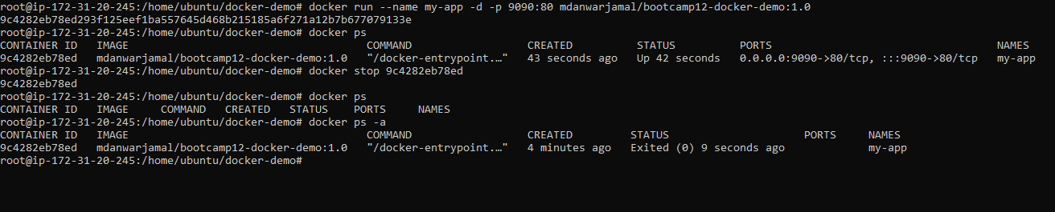

**Docker Compose**

Copying the docker-compose.yml file into directory where Dockerfile file is

**$ cd bootcamp**

**$ cp docker-compose.yml ../**

**$ cd ..**

**$ ls**

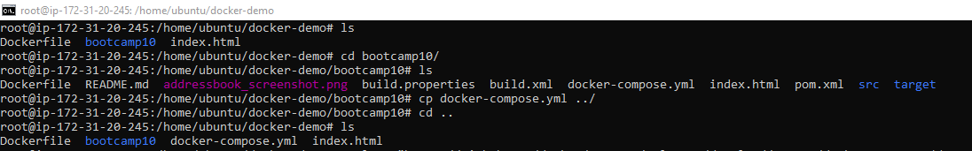

Installing docker-compose

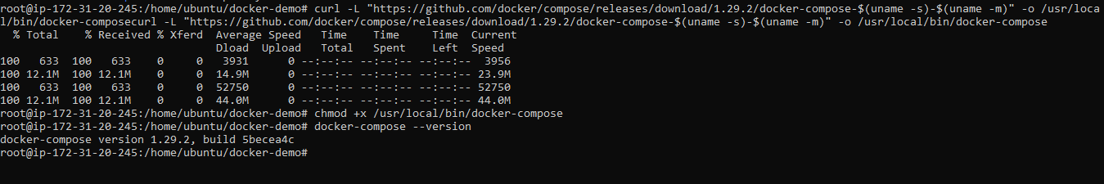

Content of **docker-compose.yml**

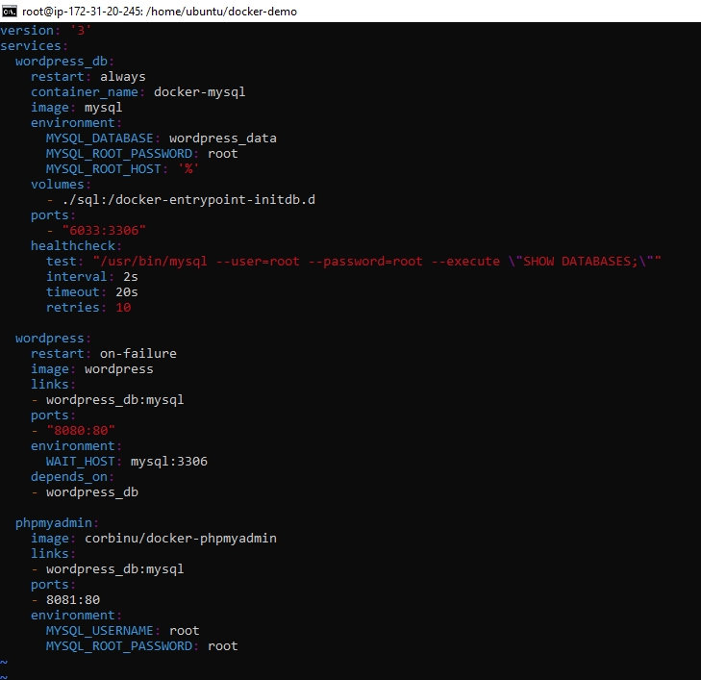

**$ docker images**

# Listing all containers before docker-compose up

**$ docker ps –a**

# Running docker-compose up –d ( -d for running as daemon process)

**$ docker-compose up -d**

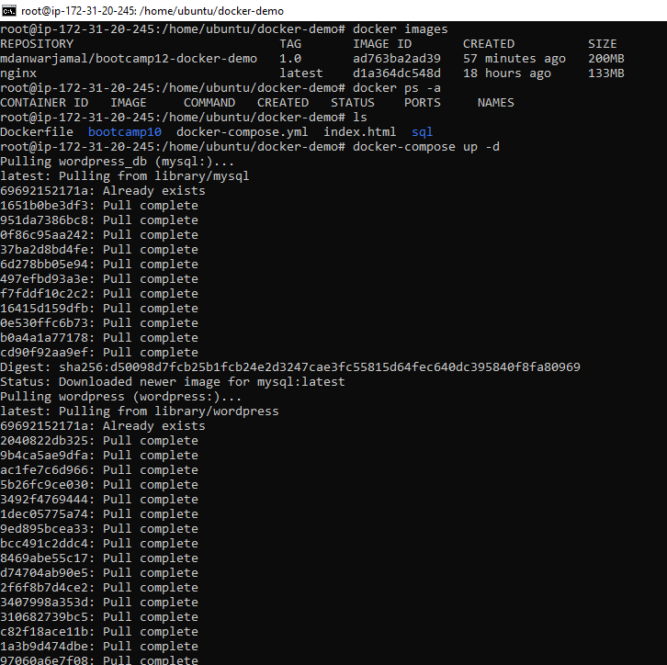

# Listing all docker images after docker-compose up is successfully run

# New images are showing up

**$ docker images**

# Listing all conatiner =s after docker-compose up is successfully run

# New containers are running

**$ docker ps –a**

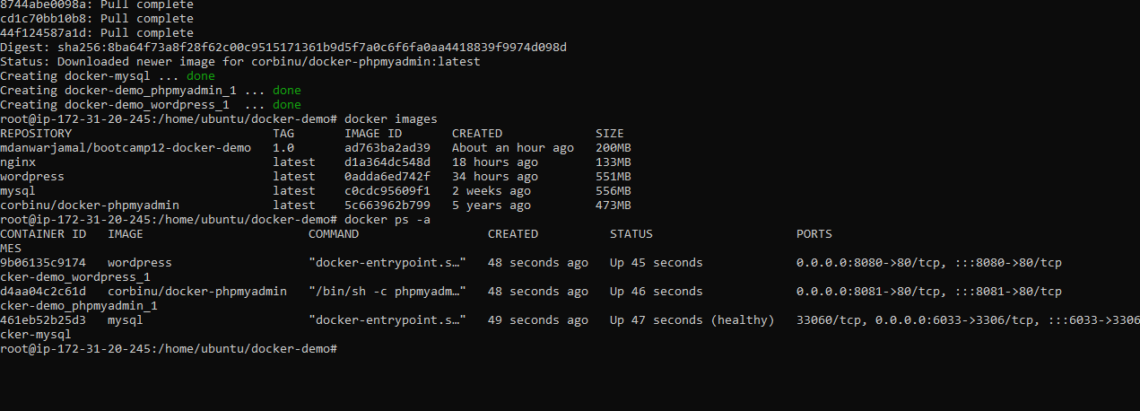

**WordPress is accessible on port 8080**

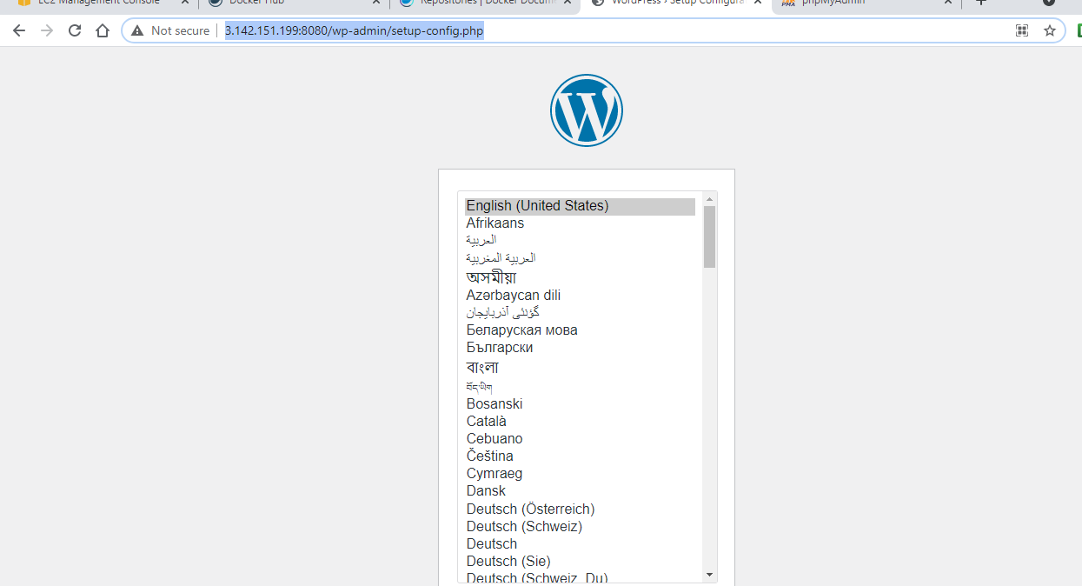

**PhpMyAdmin is accessible at port 8081**

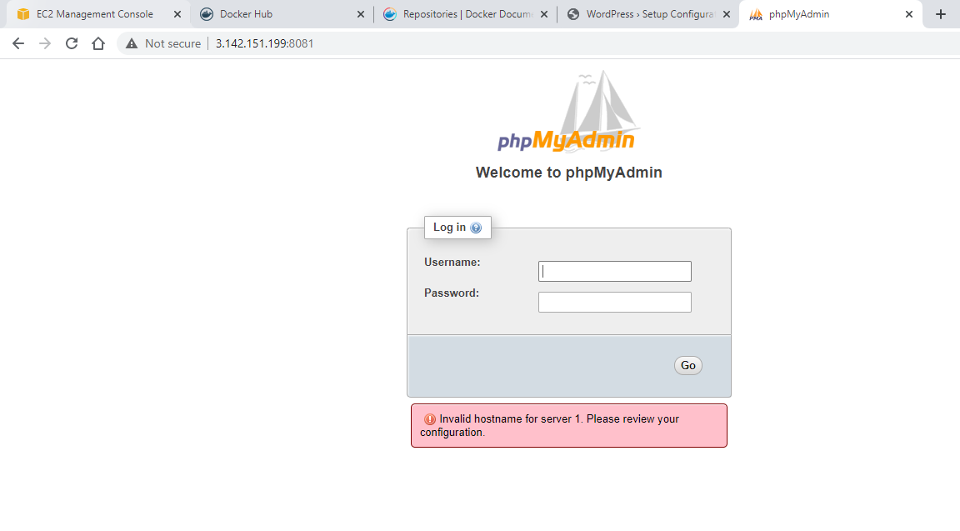

#Getting into mysql

**$ docker exec –it 461..d3 /bin/bash**

**#** Login into mysql application

**$ mysql –u root -p**

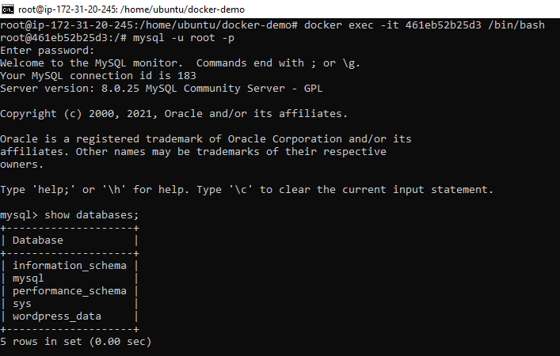

# Showing list of databases

> **show databases;**

# Selecting wordpress_data

> **use wordpress_data;**

# Creating new table called test with id, name, age attributes

> **create table test( id INT(10) PRIMARY KEY NOT NULL, name VARCHAR(50) NOT NULL, age INT(2) NOT NULL );**

# Showing list of tables for worpress_data db

> **show tables;**

#Inserting one record into table

> **insert into test (id,name,age) values (1,'Md Anwar Jamal',24);**

#Getting all records from test table

> **select * test;**

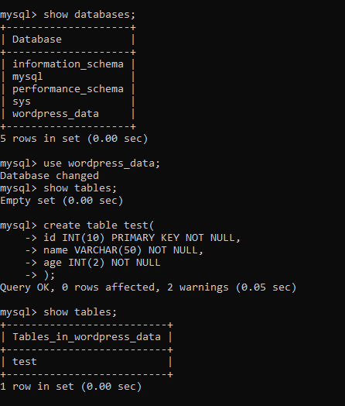

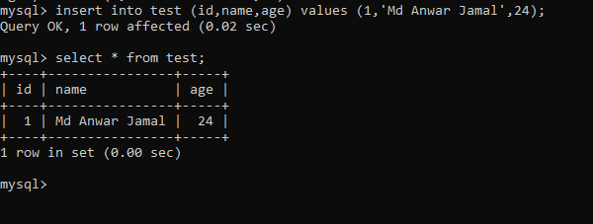

**Using Custom Docker Compose File**

# Copying existing docker-compose file to new directory called compose-demo

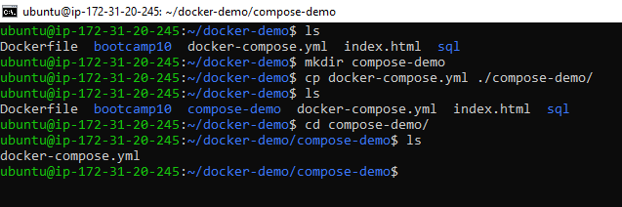

**# Writing our own docker-compose file**

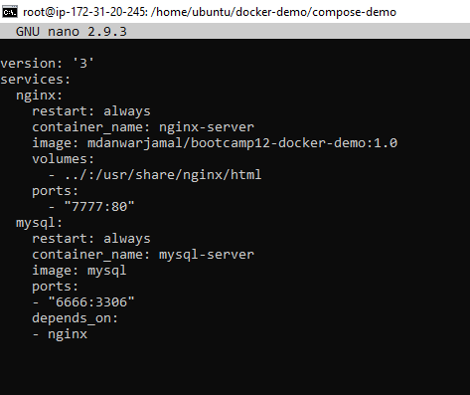

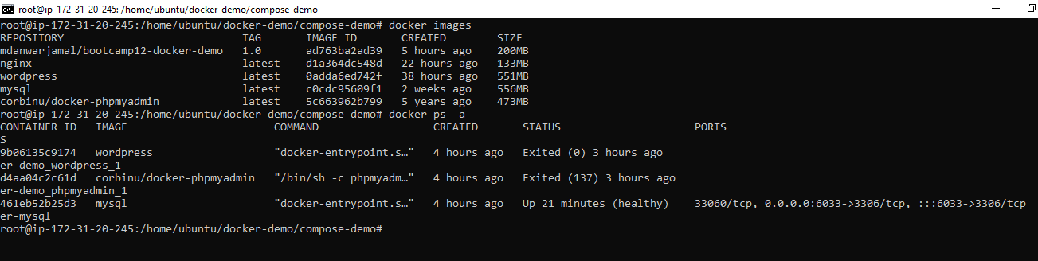

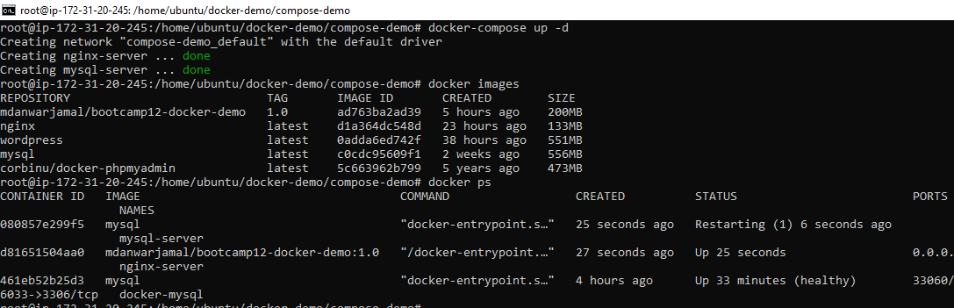

**Application is available at port 7777**

